Databricks Architecture
- The Databricks platform is built on a hybrid architecture that separates the management and control functions from the data processing and compute functions.
- It consists of a control plane, managed by Databricks in its own cloud account. And a compute plane, where data is processed. This compute plane can reside either in the customer's cloud account (Classic) or in the Databricks account (Serverless).
Core Architectural Objects
As illustrated in the first diagram, the Databricks environment is organized into a hierarchy of objects:
- Account: This is the highest-level entity that encompasses all of an organization's Databricks assets. It is used to manage identity (users, groups), workspaces, Unity Catalog metastores, and billing.
- Workspace: This is the primary environment where users collaborate to run data processing workloads, including data ingestion, analytics, and machine learning model training. An account can have multiple workspaces, often corresponding to different teams or environments (e.g., development, staging, production).
- Unity Catalog Metastore: This is the centralized data governance system for all data assets like tables and ML models.
  - It organizes data using a three-level namespace: $catalog_name.schema_name.object_name$.
  - A single metastore can be attached to multiple workspaces within the same cloud region, providing a unified view and consistent governance of data across those workspaces (as shown with Metastore A being linked to Workspace 1 and Workspace 2 in the diagram).
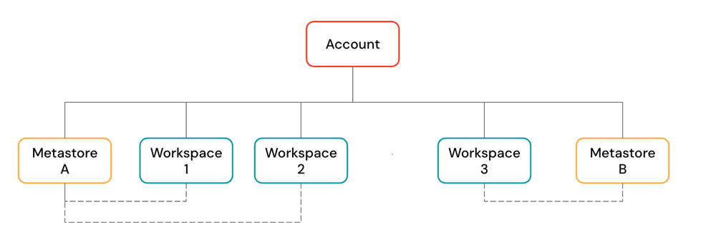
Workspace Architecture

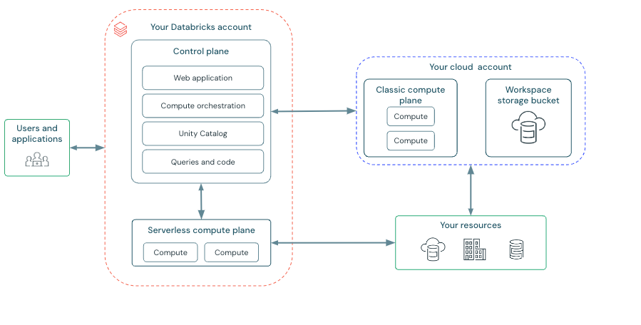
Control Plane and Compute Plane
The core of the architecture, shown in the second diagram, is divided into two main planes:
1. Control Plane
The control plane is composed of the backend services that Databricks manages within its own account. It is the brain of the platform and includes:
- Web application: The user interface for interacting with Databricks.
- Compute orchestration: Services that manage and launch compute clusters in the compute plane.
- Unity Catalog: The central service for data governance and discovery.
- Queries and code: Management of notebooks, jobs, and queries submitted by users.
Users and applications interact directly with the control plane, which then orchestrates the necessary actions in the compute plane.
2. Compute Plane
The compute plane is where the actual data processing occurs. Databricks offers two models for the compute plane:
- Classic Compute Plane:
  - In this model, compute resources (clusters) are deployed directly within your own cloud account (e.g., AWS, Azure, GCP).
  - This provides a high degree of network isolation and allows you to apply your own cloud security and networking policies.
  - The classic compute plane interacts with the Workspace storage bucket (e.g., an S3 bucket) and other data resources located in your cloud account.
- Serverless Compute Plane:
  - In this model, compute resources run in a dedicated compute layer within the Databricks cloud account, completely managed by Databricks.
  - This abstracts away the complexity of managing cloud infrastructure, offering instant and efficient compute.
  - The serverless plane is created in the same cloud region as your workspace and runs within a secure, isolated network boundary. It connects to your data resources in your cloud account to process data.
Workspace Storage
Each Databricks workspace is associated with a cloud storage location, known as the workspace storage bucket. Its implementation depends on the workspace type:
- Traditional Workspaces: You must provide a cloud storage bucket (e.g., an AWS S3 bucket) during setup. This bucket stores workspace system data (like notebook revisions and job logs), the workspace's default Unity Catalog, and the legacy Databricks File System (DBFS).
- Serverless Workspaces: These use a fully managed default storage location for system data and Unity Catalog. They can also connect to your own external cloud storage locations.

